CSCI 2670
Fall 2005
HW 1
August 30, 2005

0.3 a) no
b) yes
c) {x,y,z}
d) {x,y}
e) {(x,x),(x,y),(y,x),(y,y),(z,x),(z,y)}
f) {∅,{x},{y},{x,y}}

  - a) {(x,y) | x,y are stings of 0’s and 1’s the same number of 0’s OR 1’s}
b) {(x,y) | x ≥ y}
c)

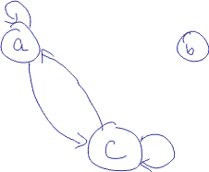

0.12 Proof by contradiction.
Let G be a graph with n≥ 2 nodes and assume all nodes of G have different degrees. Since G contains n nodes, the degree of each node must be some value in the set D={1,2,3,…,n-1}. Note that the number of values in D is n. Therefore, for each value d∈D, there is exactly one node v in G such that the degree of v is d. In particular, there is some node with degree equal to n-1. This node must have an edge to every other node in G. But this means that there can be no node with degree equal to 0. This is a contradiction since 0 ∈ D. Therefore, our assumption that all nodes have different degrees must be incorrect. I.e., there are at least two nodes with the same degree.

1.3
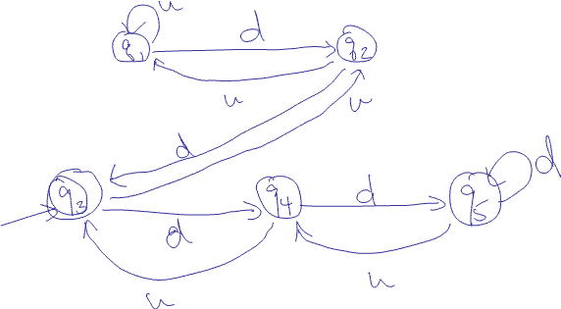

1.4 c) L(M₁) = {w | w has an even number of a’s}
L(M₂) = {w | w has one or two b’s}

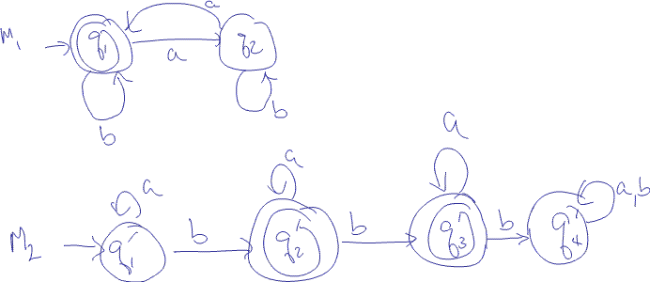

M = (Q, {a,b}, δ, q₀,F) where

Q = {(q₁,q₁’),(q₁,q₂’),(q₁,q₃’),(q₁,q₄’),(q₂,q₁’),(q₂,q₂’),(q₂,q₃’),(q₂,q₄’)}
q₀ = (q₁,q₁’)
F = {(q₁,q₂’),(q₁,q₃’)}
and δ is described by the table below
 | a | b
(q₁, q₁’) | (q_{2,}q₁’) | (q₁,q₂’)
(q₁, q₂’) | (q₂,q₂’) | (q₁,q₃’)
(q₁, q₃’) | (q₂,q₃’) | (q₁,q₄’)
(q₁, q₄’) | (q₂,q₄’) | (q₁,q₄’)
(q₂, q₁’) | (q_{1,} q₁’) | (q₂,q₂’)
(q₂, q₂’) | (q₁,q₂’) | (q₂,q₃’)
(q₂, q₃’) | (q₁,q₃’) | (q₂,q₄’)
(q₂, q₄’) | (q₁,q₄’) | (q₂,q₄’)

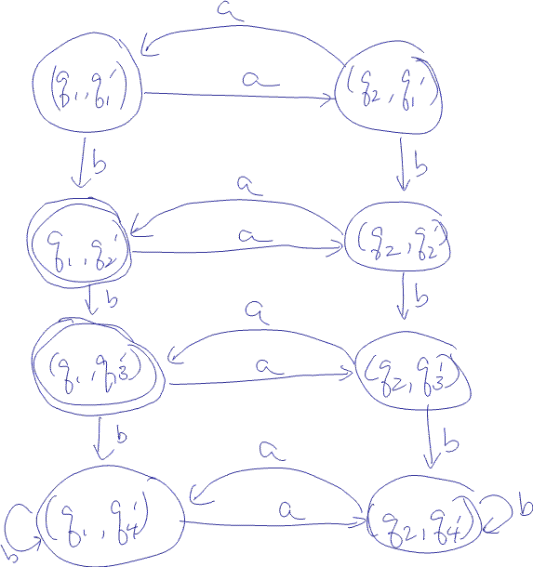

1.5 f) The simpler (complement) language is {w | w is in a* ∪ b*}. Below is the DFA
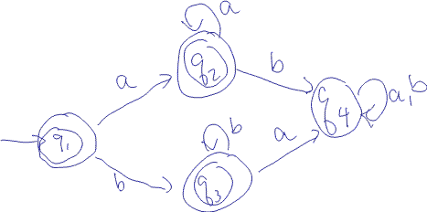

The DFA for the complement of this language would accept all strings rejected by the above DFA and reject all strings accepted by the above DFA. Therefore, the DFA that accepts strings not in a* ∪ b* will make all non-accept states in the above DFA into accept states and vice versa. The resulting DFA is below.
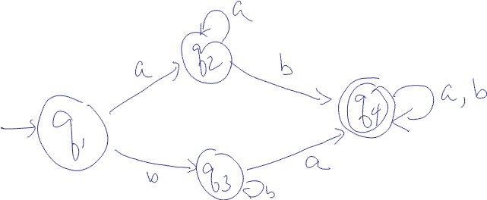

1.6 a)
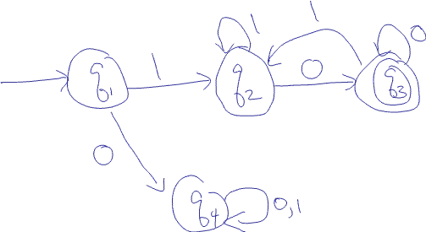
The states of this diagram have the following meanings:
q₁ no symbols processed
q₂ starts and ends with a 1
q₃ starts with a 1, ends with a 0
q₄ starts with a 0

1.6 c)
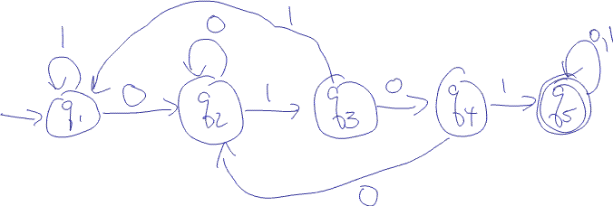
I designed this DFA by first creating the states that accept 0101. I.e., I had the 5 states and only 4 edges – the (q₁,q₂) edge labeled 0, the (q₂,q₃) edge labeled 1, and so on. I then looked at each state and added the unaccounted for edges. For example, since q₁ only had a edge labeled 0 coming out of it, I added the edge labeled 1. Clearly, some of the added edges required more thoughts than others!

1.6 h) 