CSCI 2670
Fall 2005
HW 3
September 13, 2005

1.7d 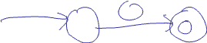

1.7h 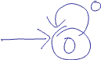

1.16b Below is the state transition table. The states in the first column that are highlighted are accept states. The start state will be {q₁, q₂} since this is the set of states that can be reached from {q₁} using 0 or more ε jumps.
 | a | b
{1} | {1,3} | ∅
{2} | {1,2} | ∅
{3} | {2} | {2,3}
{1,2} | {1, 2, 3} | ∅
{1,3} | {1, 2, 3} | {2,3}
{2,3} | {1,2} | {2,3}
{1, 2, 3} | {1, 2, 3} | {2,3}
∅ | ∅ | ∅

The DFA is below. I only include states that can be reached from the start state.
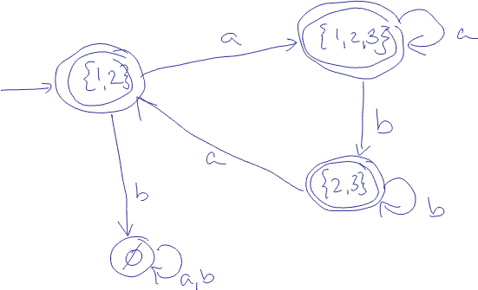
1.21b First create the GNFA from the DFA (omit ∅ transitions)
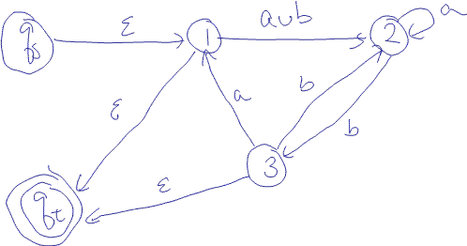

Now remove one state at a time. I chose to remove states in numerical order.

Remove state 1.

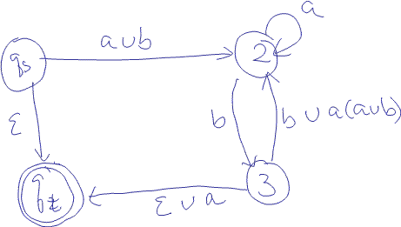

Remove state 2.

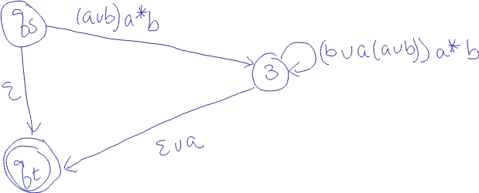

Remove state 3.
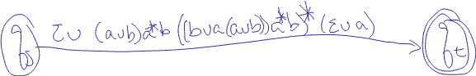

So the regular expression is ε∪(a∪b)a*b((b∪a(a∪b))a*b)*( ε∪a).

1.19a Below are the NFA’s N₁ and N₂ accepting the languages 0 and 1

Combining these to create NFA N₃ accepting 0∪1 gives

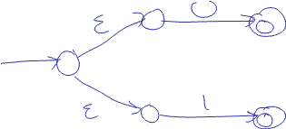

Therefore, the NFA N₄ accepting (0∪1)* is

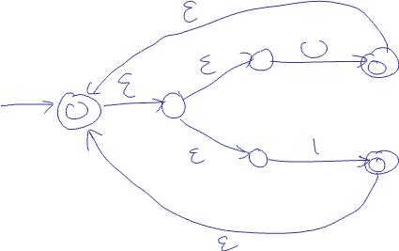
Therefore the NFA accepting (0∪1)*000(0∪1)* will be the concatenation of N₄N₁N₁N₁N₄ as shown below

